2.7 I can connect and configure the combination of IT tools and devices needed for a collaborative task

When using collaborative apps such as Microsoft Teams it is essential to have a web cam installed to fully benefit from the ability the app gives to hold virtual meetings with others. The use of a webcam allows others to see and communicate with you and vice versa if participants of the meeting are also using webcams. The webcam on my laptop is fully integrated into the device. Picture of the webcam integrated into my laptop is below;

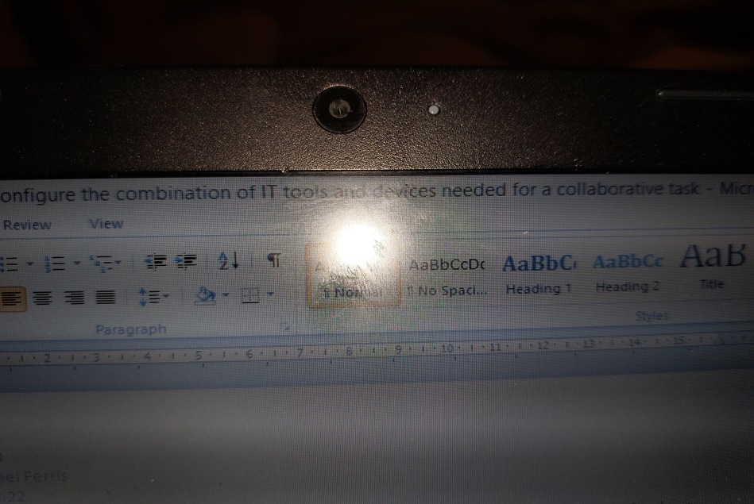

If I did not have a webcam integrated into my device I could buy an external webcam and use one of the USB ports on my laptop to connect it. Picture of USB port to attach an external webcam below;

